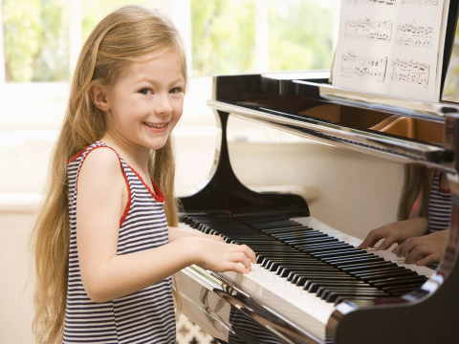

**Памятка по писанию картинки для подготовки к ВПР**

**Описание человека на фотографии**

* **I’d like to describe picture №….**
* **In this photo the action is taking place in** (*the house; the living room; the gym; the swimming pool; the theme park etc.).*
* **I can see** (a girl, a boy, a man, a woman) **in this picture.**
* **She/he** (is reading a book, is watching TV, is writing, is skating, is painting, is playing….).
* **The *girl / boy* (man/woman) looks like she/he is about … years old.**
* ***The girl (boy, man, woman) has got short (long) dark (fair)hair and beautiful blue(brown, green)*** … eyes.
* **The *girl / boy* is wearing** (a white T-shirt and blue jeans).
* It is summer (spring, autumn, winter, morning, afternoon, evening). The weather is fine (sunny, rainy, windy, cloudy).
* I think the girl (boy, man, woman) is happy (excited, sad, worried, depressed, puzzled.)
* **I like the picture because the atmosphere is peaceful.** (It is bright and colourful, full of positive emotions*.)*
* **It makes me think of***my favourite season/ my school / my family / my holidays / travelling/ my hobby/ my weekend.*
* **That’s all I wanted to say.**